# Observational study on CO2 emission and urbanization gradient in Korea

Je-Woo Hong, Jinkyu Hong*, …

Ecosystem-Atmosphere Process Laboratory, Department of Atmospheric Sciences, Yonsei University, Seoul, Korea

*Corresponding Author: Jinkyu Hong, Ecosystem-Atmosphere Process Laboratory, Department of Atmospheric Sciences, Yonsei University, Yonsei-ro 50, Seodaemun-gu, Seoul 03722, Korea.

E-mail: jhong@yonsei.ac.kr

**Abstract**

.

**Keywords**: CO2 flux, urban, suburban, mixed forest, rice paddy, double cropping, East Asia monsoon

1. **Introduction**

Urbanization and environmental changes associated therein is an essential driver of global changes now and in the future. In this context, the exchanges of carbon dioxide (CO2), water vapor, and energy between the surface and overlying atmosphere emerged as an interdisciplinary science of global changes. The characteristics of land-atmosphere interactions can widely vary with urbanization gradient even under the same climatological forcing. In the natural ecosystem, the photosynthesis is a key controlling process of surface energy and mass balance. Therefore, the canopy structure (i.e., species, density, ages, leaf area index, under canopy, and soil properties, etc.) and physiological function (i.e., light use efficiency, water use efficiency, and nutrients, etc.) can explain the spatial-temporal variation of surface fluxes. However, human alteration of the Earth’s surface (e.g., urbanization, resource consumption for food, fuel, and shelter) overwhelms the magnitude and speed of natural changes and makes an unprecedented impact on the land-atmosphere interactions.

Since the industrial revolution, CO2 emission by anthropogenic activities (i.e., fossil fuel combustion and land use change) increases and the amount of anthropogenic CO2 emission reaches about 10.7 GtC yr-1 over the last decade (Le Quéré, 2018). The anthropogenic CO2 emission on continent-to-country spatial scale and annual temporal scale is well known with energy consumption data (Andres et al., 2012) and its magnitude is increasing exponentially with the gross domestic product (Martinez-Zarzoso and Maruotti, 2011; Zhu et al., 2012). The net ecosystem CO2 exchanges and surface CO2 balances on high spatial and temporal resolution involve relatively large uncertainty.

With the micrometeorological method, over the last three decades, a lot of research has been going on in-situ monitoring of surface CO2 flux from various land covers (Baldocchi et al., 2001). There are more than three hundred of monitoring sites in the world, nevertheless, clear gap on measurements over East-Asian cities and rice-paddy hinders us reducing the uncertainty of surface CO2 balances in this region. Here we present the in-situ observation data of surface CO2 flux following urban gradients in Korea: from urban, suburban, rice-paddy, and mixed forest sites. (- 논문의 의의를 더 써야 합니다.)

The rest of paper is organized as follows: section 2 describes sites description, instrumentation and data processes, section 3 shows measurement results and section 4 concludes with summary and discussion.

1. **Site and Methods**

**2.1. Surface CO2 Balances**

*FC* + *dS* = *C* + *RE* − *P* (μmol m−2 s–1) (1)

The eq. (1) shows the surface CO2 balances over the urban area (Feigenwinter *et al.*, 2012), where, *dS*, *C*, *RE*, and *P* are concentration change of CO2 in the control volume, CO2 emission from fossil fuel combustion, respiration by soil, vegetation, and humans, and CO2 uptake by photosynthesis, respectively. *dS* can be neglected by the stationary assumption of the eddy covariance method; therefore, the observed *FC* is the well-mixed sum of *C*, *RE,* and *P*, representing the neighborhood spatial-temporal scale in the upwind direction. The impact of *C* is negligible at the station over natural ecosystem, such as BoSeong (rice-paddy) and Jeju (forest) in this study. The sign convention of micrometeorology is used, therefore positive sign indicates CO2 emission from surface to atmosphere and negative sign is appeared with CO2 uptake by plant photosynthesis.

**2.2. Site Description**

(Figure 1)

(Table 1)

The measurements undertaken at four sites in Korea. These are a high-rise high-density residential area in EunPyeong, Seoul (U: 37.6350oN, 126.9287oE; Fig. 1a), an open low-rise research park in Ochang, Cheongju (S: 36.7197oN, 127.4344oE; Fig. 1b), a double-cropping rice-paddy in BoSeong, Jeollanam-do Province (R: 34.7607oN, 127.2140oE; Fig. 1c), and a mixed forest in Jeju island (F: 33.3177oN, 126.5678oE; Fig. 1d). There is an urban gradient across the sites, where the 60% of land cover is buildings and roads at the EunPyeong, meanwhile about 36% at Ochang and it is negligible (<1%) at BoSeong and Jeju. The mean obstacle (i.e., buildings and vegetation) height (zH) is higher at EunPyeong (~20 m) and Jeju (~13.7 m) and relatively shorter at Ochang (~4 m) and BoSeong (<1 m) (Table 1). For the planted land cover, dominant plant functional type is deciduous broad-leaf trees (*Zelkova serrata*, *Cornus officinalis*, etc.) at EunPyeong, C3 grass (*Zoysia japonica*) at Ochang, C3 crop (*Oryza sativa*: June–November; *Hordeum vulgare*: December–May) at BoSeong, and deciduous broad-leaf trees (*Carpinus tschonoskii*, *Quercus serrata*) at Jeju, respectively. Additional site description for EunPyeong (U) can found in Hong and Hong (2016) and Hong et al. (2018, in progress).

**2.3. Instrumentation and Data Process**

**2.3.1. Instrumentation**

Eddy covariance method is applied for monitoring of *FC* at each site (Table 1). 3-d sonic anemometer (CSAT-3, Campbell Sci., US) and infra-red gas-analyzer (IRGA) are installed for measuring wind components, sonic temperature, humidity, and CO2 concentration. The 10-Hz raw-data are recorded by data logger (CR-3000, Campbell Sci., US). The closed-path IRGA is used at EunPyeong (Li-7200, Li-COR, US) and Jeju (EC-155, Campbell Sci., US), and open-path IRGA (EC-150, Campbell Sci., US) is used at Ochang and BoSeong. 30-min averaging values of solar radiation, downward/upward short/long-wave radiation, is measured by net-radiometer (CNR-4, Kipp&Zonen, Netherlands).

**2.3.2. Flux process**

Turbulent fluxes were computed by EddyPro software (version 6.2.0, Li-COR, US) with a 30-min averaging period. The magnetic declination angle was considered to calculate the wind direction. Double rotation, spike removal (Vickers and Mahrt, 1997), and spectral correction (Moncrieff et al., 2004; Fratini et al., 2012; Horst and Lenschow, 2009) were applied. In the post-processing, outliers in the 30-min CO2 fluxes were discarded and negative (absorption) fluxes during nighttime were excluded from analysis (Papale et al., 2006; Hong et al., 2009; Hong and Hong, 2016). After quality control, data availability is about 97 % for EunPyeong, 52 % for Ochang, 63 % for BoSeong, 69 % for Jeju, respectively. For convenience, this study uses LST (Local Standard Time) which is 9 hr ahead of UTC (Universal Time Coordinated).

**2.3.3. Gap filling**

Flux gap is filled with artificial neural network (ANN) method (Papale and Valentini, 2003; Lee, 2015) using Deep Learning Toolbox of MATLAB software. In this study, multi-layer perceptron network method is applied and one hidden layer and 9 neurons for hidden layer are used with backpropagation algorithm. The fraction of training data and independent test-set are 80% and 20%, respectively. The variables used in the gap filling procedure are: 1) hour and 2) season (fuzzy system using cosine transformed time of day and day of year), 3) 1.5 m air temperature (Tair), 4) 1.5 m relative humidity (RH), 5) 10 m wind-speed and 6) wind-direction, 7) downward shortwave radiation (KDN), and 8) precipitation. Meteorological variables are achieved from adjacency weather observatories of each flux site: Seoul (37.5714oN, 126.9658oE), CheongJu (36.6392oN, 127.4407oE), BoSeong-gun (34.7633oN, 127.2123oE), and Seogwipo (33.2461oN, 126.5653oE) for EunPyeong, Ochang, BoSeong, and Jeju, respectively. Quality-controlled meteorological data are opened through the National Climate Data Portal of Korea Meteorological Administration (KMA) (http://data.kma.go.kr/).

**2.3.4. Quantification of random error**

Characterizing the random error (*ε*) of the measured fluxes is essential for model validation, parameter optimization, and estimating statistical confidence in the measured fluxes. This study quantifies the total random uncertainty in the measured turbulent fluxes and its covariant properties with environmental changes (e.g., meteorological variations) by applying the daily differencing approach (Hollinger and Richardson, 2005; Richardson *et al*., 2006). If a measurement flux (*x*) pair of two successive days (*x1*=*F*+*ε1*, *x2*=*F*+*ε2*, and *F* is the true flux) are under equivalent environmental conditions, the standard deviation of random error (*σ*(*ε*)) can be written as:

*σ*(*ε*) = *σ* (2)

For this daily differencing method, similar environmental conditions are assumed for 24-h differences in downward shortwave radiation within 100 W m−2, air temperature within 2 °C, and wind speed within 0.5 m s−1 in the same wind direction sector (135–315°). More information on the random flux error estimation is found in Hollinger and Richardson (2005).

**2.4. Climate Condition**

(Figure 2)

Weather stations considered in this section include aforementioned adjacency weather observatories of each flux site (in section 2.3.3). Despite a distance, which is up to 450 km (EunPyeong – Jeju), the climate conditions and seasonal patterns of four sites are similar.

Daily mean Tair across four sites are visible in Fig. 2a. The annual (March 2015 – February 2016) Tair is about 13.3, 13.8, 14.5, and 16.5 oC over EunPyeong, Ochang, BoSeong, and Jeju, respectively, which is +0.8, +1.3, +0.9, and -0.2 oC than normal period of 1981 – 2010. Mean Tair of Jeju is similar with normal, but it of others have significantly increased. The regional precipitation differential, the difference between north (EunPyeong and Ochang) and south (BoSeong and Jeju), was large in the study preriod. The annual precipitation is 806.7, 765.6, 1281.0, 2575.1 mm yr-1 for EunPyeong, Ochang, BoSeong, and Jeju, respectively, which is 56, 62, 88, and 134 % of normal. Therefore, the RH of Jeju is usually higher than other sites (Fig. 2b). The summer rainfall was below-normal from all sites, but due to the Changma, the KDN decreased during this season (Fig. 2c).

1. **Results**

**3.1. CO2 flux along an urban gradient**

(Figure 3)

(Figure 4)

There is a distint difference in CO2 flux between the sites (Fig. 3 and Fig. 4). In the case of EunPyeong urban site, CO2 emissions from the ground to the atmosphere continued throughout the year, but in Ochang suburban site, the daytime CO2 absorption during March – October was clearly observed. BoSeong cropland and Jeju forest site are considered to CO2 sink throughout the year. BoSeong showed a sharp change in CO2 flux due to double-cropping farming (sowing and harvesting), however, the seasonal variation in CO2 flux based on the growing season of deciduous trees (leaf out: early May, leaf falling: late October) is observed in Jeju.

The seasonal variation of CO2 flux is relatively small at EunPyeong site compared to other observatories (Fig. 4a), mainly the CO2 emission is concentrated from sunrise to early evening when people were active, and the maximum CO2 emission rate was observed at about 25 μmol m-2 s-1 in the afternoon (Fig. 3a). Ochang showed that the maximum CO2 absorption rate during daytime was approximately -10 μmol m-2 s-1, while the maximum CO2 emission rate at night was about 10 μmol m-2 s-1 during the grass's growing period (Fig. 3b). BoSeong has shown a bimodal seasonal variation as of the period from mid-May (harvest of barley) to early-June (planting of rice) (Fig. 3c and Fig. 4c). From April – May (the mid-growing period of barley) the maximum CO2 absorption rate was about -20 μmol m-2 s-1 in midday, and about -40 μmol m-2 s-1 was observed for rice in July – August. The Jeju Forest showed strong CO2 absorption from the end of May to October, and the maximum CO2 absorption rate was -25 μmol m-2 s-1 (Fig. 3d and Fig. 4d).

**3.2. Light use efficiency**

(Figure 5)

Figure 5 shows light-response curve during the growing season: May – September for urban, suburban, and forest site, April – May for barley, and July – September for rice at the cropland site. There is no relationship between FC and photosynthetic active radiation (PAR) at EunPyeong site. However, other sites have shown a tendency to increase CO2 absorption as PAR increases. In Ochang site, when PAR reaches about 500 μmol m-2 s-1 (KDN = about 140 W m-2), CO2 absorption compensates the CO2 emissions from nearby buildings and roads, resulting in a carbon neutral state. The maximum CO2 absorption rate of about -6 μmol m-2 s-1 was shown at the maximum value of PAR. Cropland and forest sites showed a similar increase in absorption from the low-PAR range to approximately 300 μmol m-2 s-1 (KDN = about 230 W m-2), while barley showed a lower light use efficiency than rice and forest in a larger PAR range. The light-response curve of forest site had a similar form to that in the previously reported temperate forests (Schmid et al., 2000; Ward et al., 2015), but interestingly, the rite did not reach light saturation, and the photosynthesis rate continued to increase as the PAR intensifies. Normally, plants absorb CO2 through their stomata for photosynthesis, and they lose H2O saturated inside the stomata by transpiration at the same time. To reduce moisture loss, the light-response curve represents a rectangular hyperbola curve where the increasing rate in photosynthesis gradually decreases as PAR becomes stronger. This water stress didn't appear in the rice field, probably because the rice paddy is flood-irrigation and the top-soil is always immersed in water.

**3.3. Temperature response**

(Figure 6)

(Figure 7)

**3.4. Annual surface CO2 exchange**

(Figure 8)

1. **Summary and Conclusions**

.

**Acknowledgements**

This study was supported by the Korean Meteorological Administration Research and Development Program (KMIPA2015–2063). The first author was supported by the Global Ph.D. Fellowship Program (NRF–2015H1A2A1030932). We thank Prof. Sue Grimmond for discussion which improves this manuscript.

**References**

.

**Table Captions**

**Table 1.** Site characteristics and instrumentation details for the study sites.

**Figure Captions**

**Figure 1.** Location of study sites: (a) EunPyeong (red, urban residential area), (b) Ochang (orange, suburban research complex area), (c) BoSeong (blue, rice-paddy), and (d) Jeju (green, mixed forest) site.

**Figure 2.** Climate condition at the study sites: (a) air-temperature (Tair), (b) relative humidity (RH), and (c) downward shortwave radiation (KDN) as a daily mean value.

**Figure 3.** aa

**Figure 4.** aa

**Figure 5.** aa

**Table 1.** Site characteristics and instrumentation details for the study sites.

|  |  |  |  |  |  |
| --- | --- | --- | --- | --- | --- |
|  | | **EunPyeong (U)** | **Ochang (S)** | **BoSeong (R)** | **Jeju (F)** |
| Location | Latitude (oN) | 37.635 | 36.7197 | 34.7607 | 33.3177 |
| Longitude (oE) | 126.9287 | 127.4344 | 127.2140 | 126.5678 |
| Classification | | Urban | Suburban | Rice-paddy | Mixed forest |
| Description | | High density high-rise residential area | Open low-rise research park | Double cropping  - Dec-May: *Hordeum vulgare*  - Jun-Nov: *Oryza sativa* | Deciduous (82%)  - *Carpinus tschonoskii*, *Quercus serrata* |
| Population density (km-2) | | ~15,000 | 770 | <50 | ~0 |
| Building and road fraction (%) | | ~60 | 36 | <1 | <1 |
| Vegetation fraction (%) | | ~40 | 64 | ~100 | ~100 |
| Measurement height (m) | | 30 | 19 | 2.5 | 27 |
| Obstacle height (m) | | ~20 | ~4 | <1 | ~13.7 |
| Altitude (m) | | 60 | 60 | 2 | 635 |
| Sonic anemometer | | CSAT3, Campbell Sci. | CSAT3, Campbell Sci. | CSAT3, Campbell Sci. | CSAT3, Campbell Sci. |
| Infrared gas analyser | | Li-7200RS, Li-COR | EC-150, Campbell Sci. | EC-150, Campbell Sci. | EC-155, Campbell Sci. |
| Radiometer | | CNR-4, Kipp&Zonen | CNR-4, Kipp&Zonen | CNR-4, Kipp&Zonen | CNR-4, Kipp&Zonen |
| Data logger | | CR-3000, Campbell Sci. | CR-3000, Campbell Sci. | CR-3000, Campbell Sci. | CR-3000, Campbell Sci. |
| Establishment | | May 2013 | July 2014 | September 2014 | May 2014 |

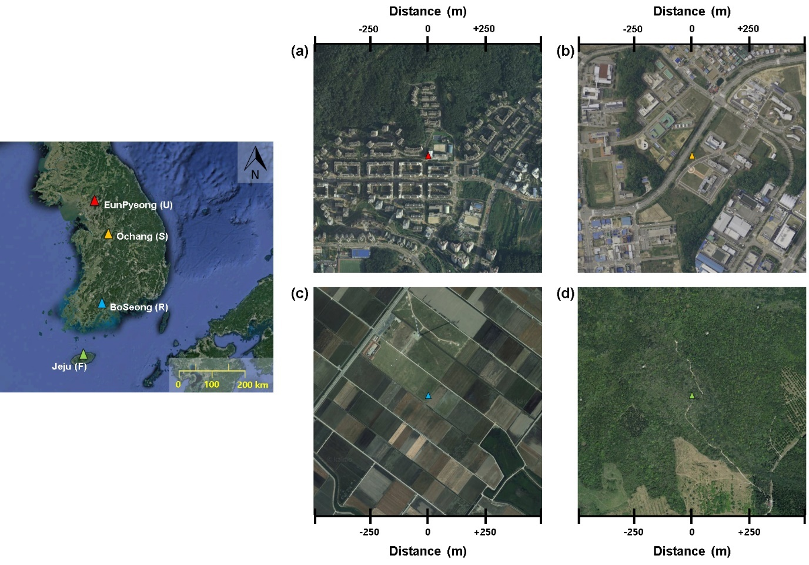

**Figure 1.** Location of study sites: (a) EunPyeong (red, urban residential area), (b) Ochang (orange, suburban research complex area), (c) BoSeong (blue, rice-paddy), and (d) Jeju (green, mixed forest) site.

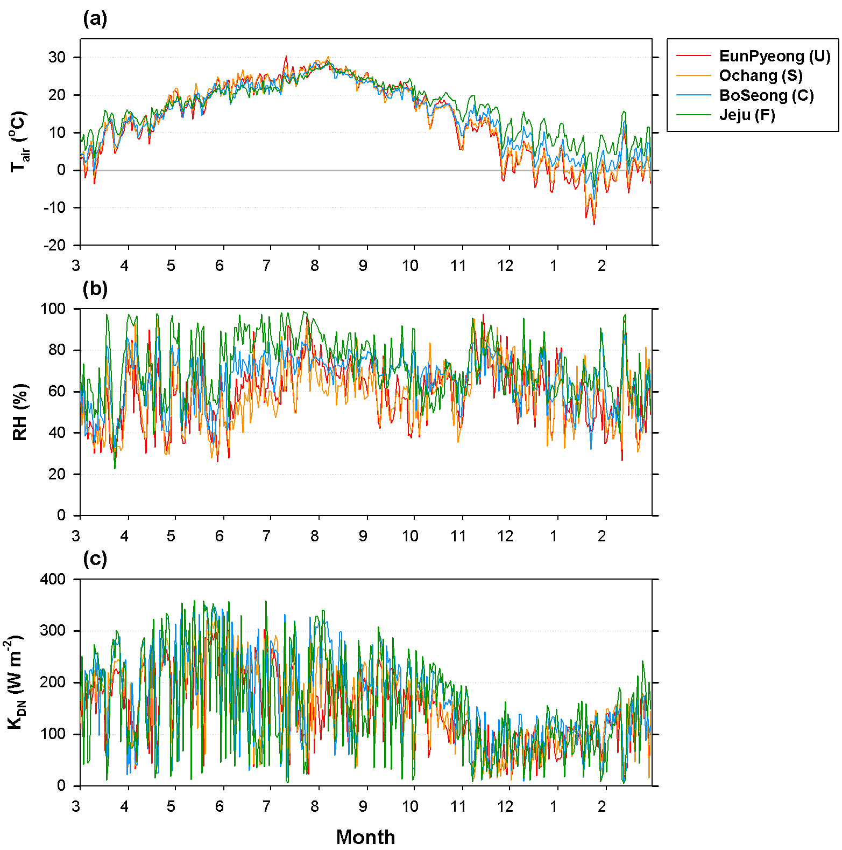

**Figure 2.** Climate condition at the study sites: (a) air-temperature (Tair), (b) relative humidity (RH), and (c) downward shortwave radiation (KDN) as a daily mean value.

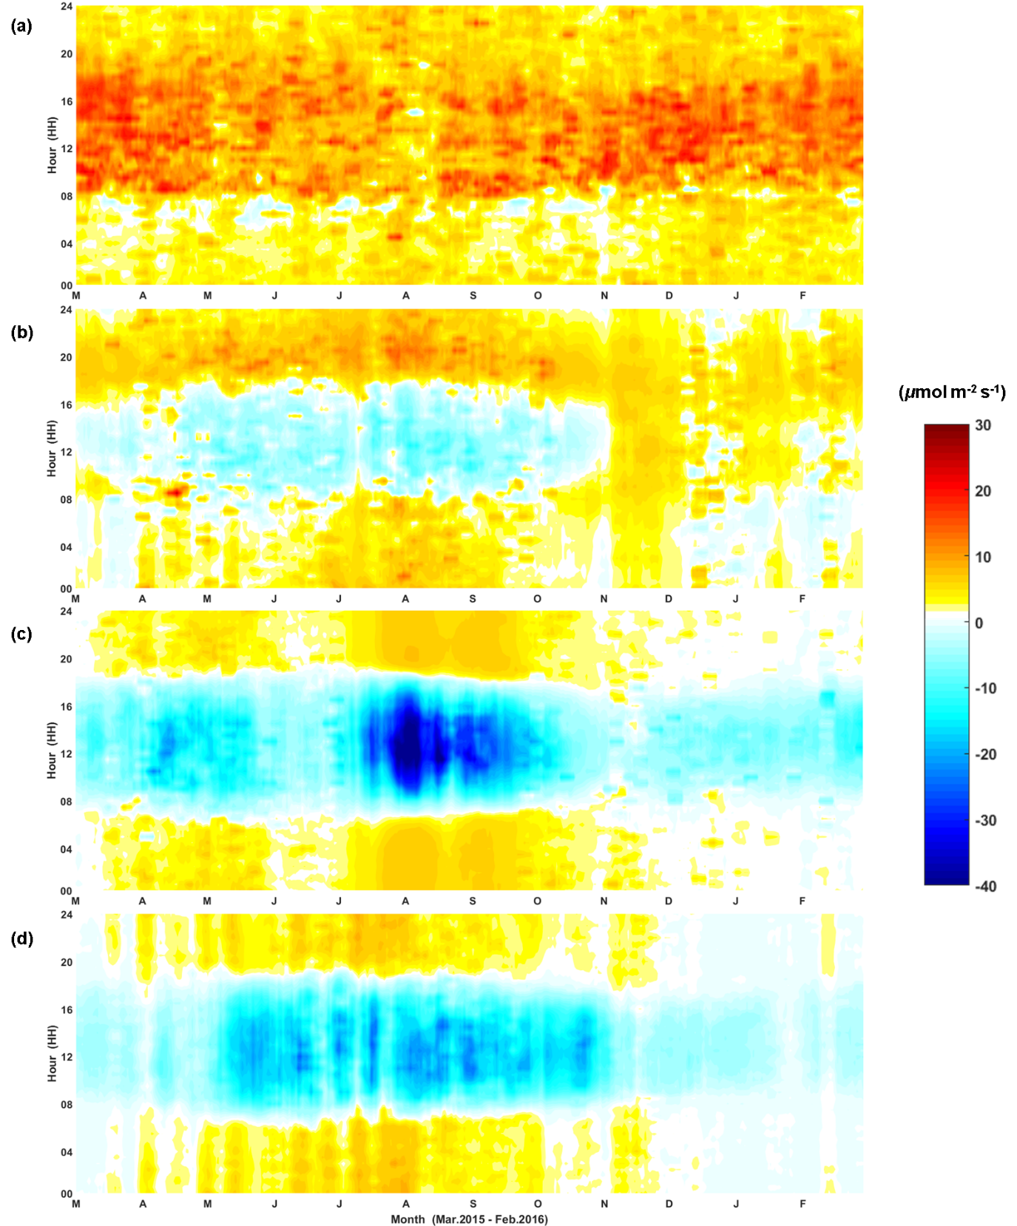

**Figure 3.** CO2 flux during one year at the four sites as 7-day moving average.

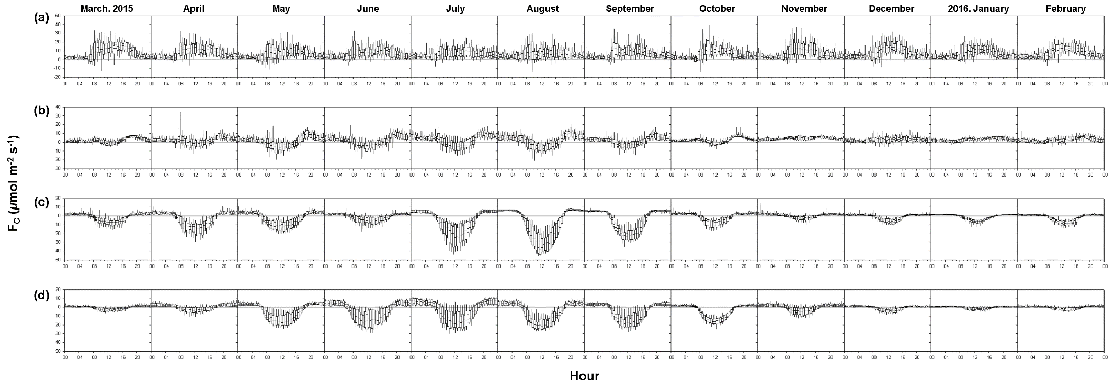

**Figure 4.** Monthly mean diurnal pattern of CO2 flux during one year at the four sites with median, interquartile range (box), and 5th and 95th values (whiskers).

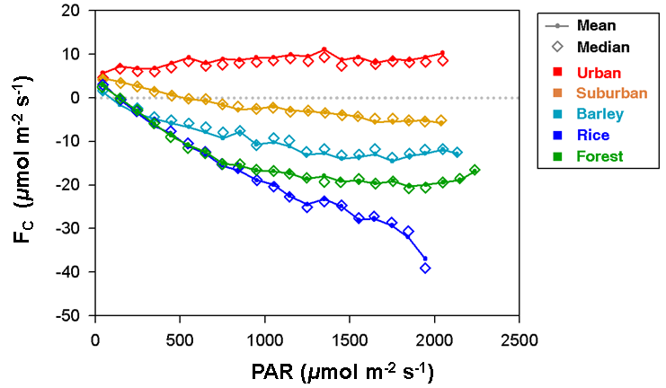

**Figure 5.** Light-response curve for growing season: May – September for urban, suburban, and forest sites; April – May for barley and July – September for rice at the cropland site. Photosynthetically active adiation (PAR) is estimated with observed downward shortwave radiation (KDN) ().

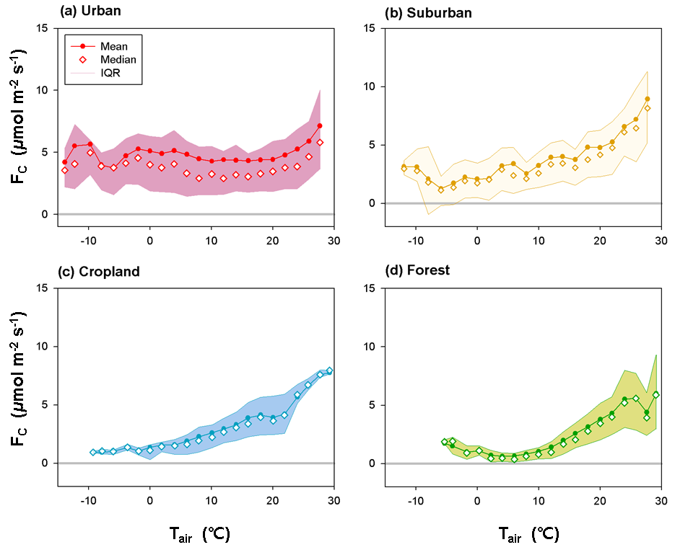

**Figure 6.** Temperature-response curve for nocturnal CO2 flux at the four sites.

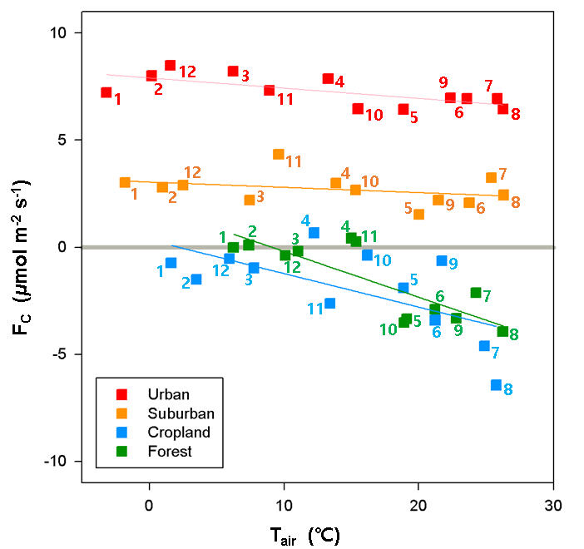

**Figure 7.** The relationship between monthly mean CO2 flux (FC) and monthly mean air-temperature (Tair) during one-year at the four sites. The numbers (1-12) indicate month.

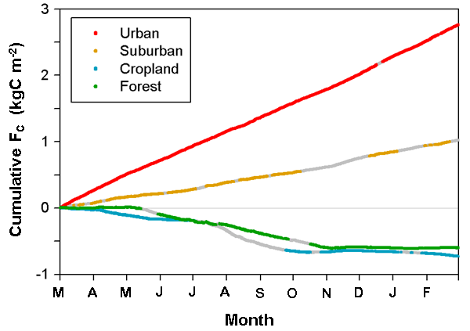

**Figure 8.** Accumulated CO2 flux (FC) during one year for four sites. Grey points indicate gap-filled data.